Propagation:
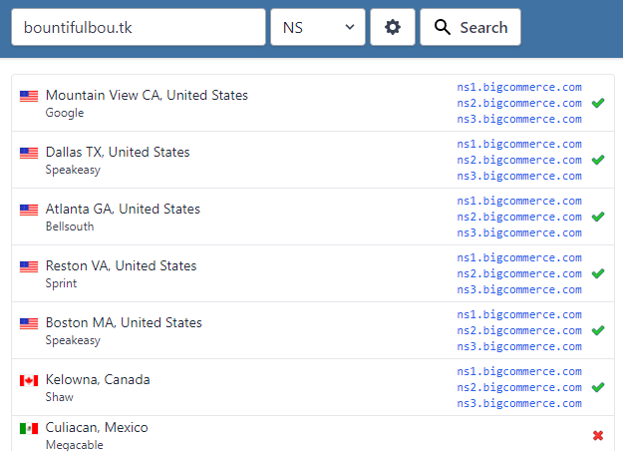
Map:
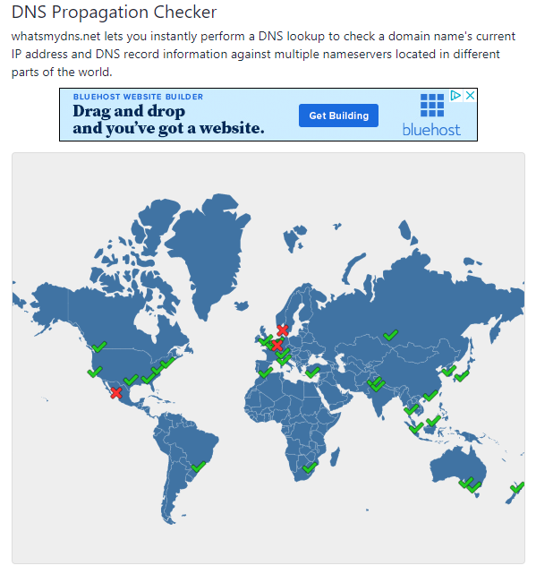
WhatsMyDNS is a great tool for verifying that someone’s nameservers are pointed in the right direction as well as finding out how far along the propagation path they are.

The information is provided in two different ways. The text shows a) the location of the servers being checked, and b) the current nameservers listed there for the site. The map is simply a visual representation of what is listed in the text.

When used with leafdns, this tool is great for checking why a merchant’s custom domain doesn’t show up in a particular area. Leafdns will show what the nameserver currently is, and WhatsMyDNS will show whether that’s reflected in the necessary places.

Of note: if a server has an X, it simply means that the nameserver information is not listed there at all. This doesn’t guarantee that it will prevent the site from being loaded, only that if it loads it will take longer.

